Data*6200 Final Project Proposal

Evan Switzer

**Introduction:**

Questions of Interest:

* What makes a first overall draft pick special?
* Are there different kinds of players that end up first overall and if so, what are the differences?
* Can we predict future how well future first overall picks do?

Data:

NHL Stats API – This comes directly from the official National Hockey League, providing almost any stats that could be needed. I want this specifically because it can give goal location. [stats-api.md · master · Drew Hynes / nhlapi · GitLab](https://gitlab.com/dword4/nhlapi/blob/master/stats-api.md)

NHL Draft Hockey Player Data – This gives info about players who were drafted into the NHL. Things like games, goals, team, and overall pick are all useful for me. The above API may also have this so this is for a starting point and to make it so I don’t need to just straight into the deep end. [NHL Draft Hockey Player Data (1963 - 2022) (kaggle.com)](https://www.kaggle.com/datasets/mattop/nhl-draft-hockey-player-data-1963-2022)

Variables:

|  |  |
| --- | --- |
| Variable | Description |
| Overall_pick | Overall pick player was drafted |
| team | Team player was drafted to |
| Year | Year of the draft |
| player | Player drafted |
| nationality | Nationality of player drafted |
| Age | Player age |
| Games_played | Total games played by player |
| goals | Total goals |
| assists | Total assists |
| points | Total points |

|  |  |
| --- | --- |
| Variable | Description |
| Game_id | Unique identifier for each game |
| shooter | Player who scored the goal |
| x | X location of the shot that ended up as a goal |
| y | Y location of the shot that ended up as a goal |

**Motivation:**

Hockey is a major area of personal interest to me. It is one of the more random sports which makes currently hard to predict with statistics. Recently Connor Bedard was drafted 1st overall and has been called one of the best player since Connor McDavid entered the league (maybe it’s the name Connor?). I want to figure out what sets them apart from the normal player, and if it is possible to look at history and see how well new players will do. The NHL API has so much data and this project I am using to make a small part of that easily digestible to me and the normal person.

**Design:**

I am going to create a couple tables, a line graph, and one heat-map ideally. If I get ideas of more, I will most likely add them if I have time. If I were to spend forever on this, I would like to have a entirely separate page with similar tables and heatmaps to compare players.

I will have a table showing the stats of first overall draft picks through the years.

|  |  |  |  |  |  |
| --- | --- | --- | --- | --- | --- |
| Player | Year | Goals | Assists | Points | Games Played |
| McDavid | 2015 | 305 | 554 | 859 | 575 |
| Bedard | 2023 | 3 | 2 | 5 | 8 |

The line graph will compare each round of the draft and how successful they were. It will average all the players for that round and give them each their own line. It will go year by year. There will be an option to select what is on the vertical axis.

I would like to have a drop down menu to select and first overall draft pick. Once selected a heatmap will be populated and a description of the player will also show up.

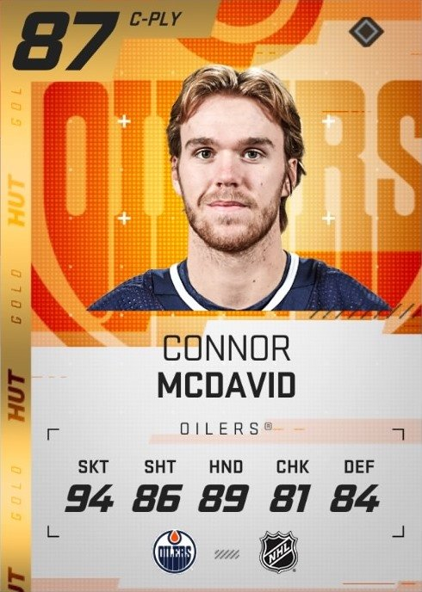It would look like this but with relevant stats and less fancy graphics.

Heatmap of goals

There is a website that has done a similar thing to this but only for the 2019-20 NHL season [NHL Hot Shots 2019-20 (google.com)](https://lookerstudio.google.com/reporting/8fd0c99c-0a60-4e28-acd3-a7763ebad1e1/page/mDAOB?s=kJKZx3ROjns).

Apologies for the 3 pages, tables and images took up a lot of space.